**How to set some of the Fine-tune configuration parameters.**

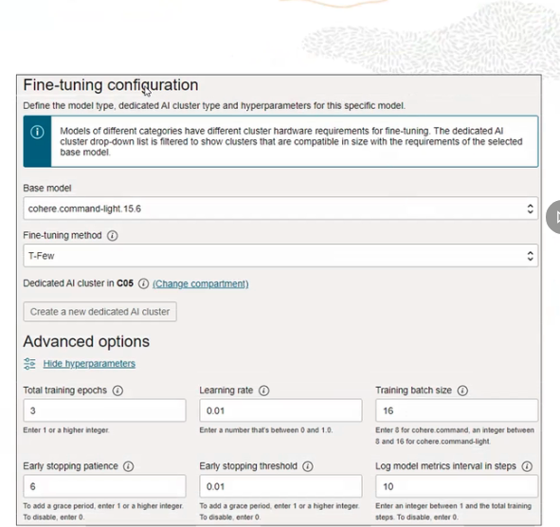

**what parameters you can set when you do fine tun e configuration:**

1. You choose the base model

2. Choose fine tuning method (ethier vanilla or T-Few)

3. And then you choose Hyperparameters

You can start training a model with default hyperparameter values.

**How do they look like?**

Vanilla fine-tuning, which is the traditional fine-tuning method. And also support the T-Few fine-tuning method, which is the few shot parameter efficient fine-tuning method. It's an efficient fine-tuning method.

*You can start training a model with default hyperparameter values. After the model is created in the Models Detail page, under Model Performance, you can check the values for accuracy and loss. If you are not happy with the results, you can create another model with either a larger data set, or you can change these hyperparameters until the performance improves. So this is basically how you should think about these hyperparameters.

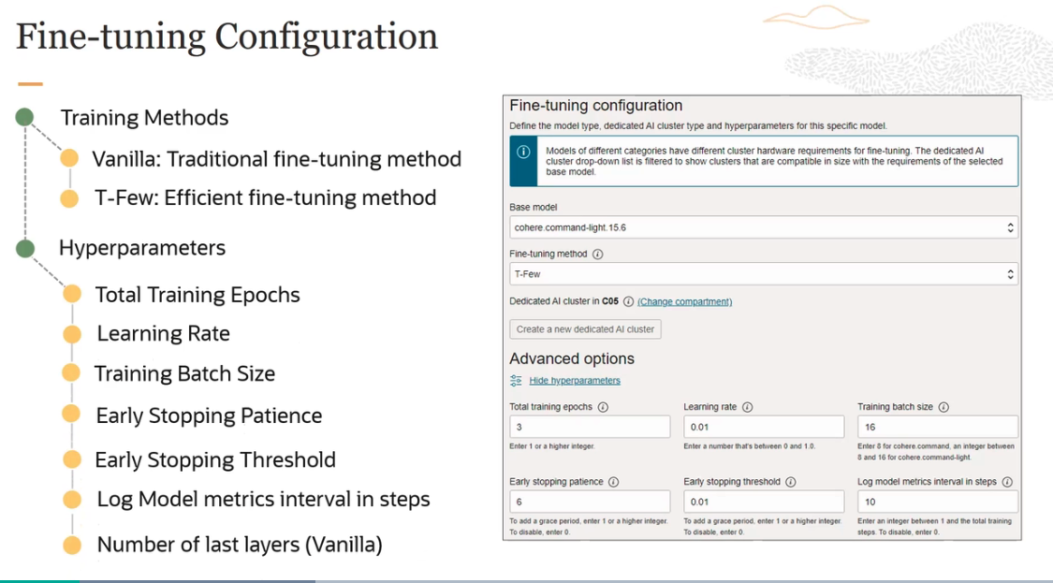

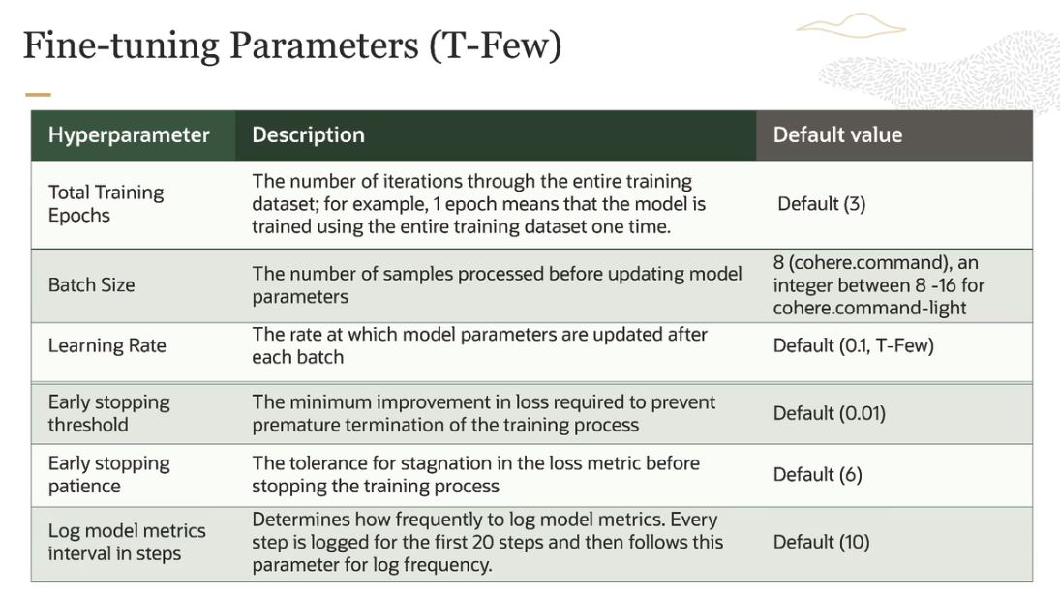

**How you can figure out if your results are good or not?**

There are two matrix we use.

- The first one is accuracy. The second one is loss. Accuracy is a measure of how many predictions the model made correctly, out of all the predictions in an evaluation. Now, how do we do this? To evaluate generative models for accuracy, we ask it to predict certain words in the user uploaded data. And then we see whether it's doing a good job there or not.

-The second metric is called loss. And loss is a measure that describes how bad or wrong a prediction is. Now, accuracy may tell you how many predictions the model got wrong, but it will not describe how incorrect the wrong predictions are. To evaluate these generative models for loss, we ask the model to predict certain words in the user-provided data, and evaluate how wrong the incorrect predictions are. So that's how we figure out what loss is.

- And the rule of thumb here is the loss should decrease as the model improves.

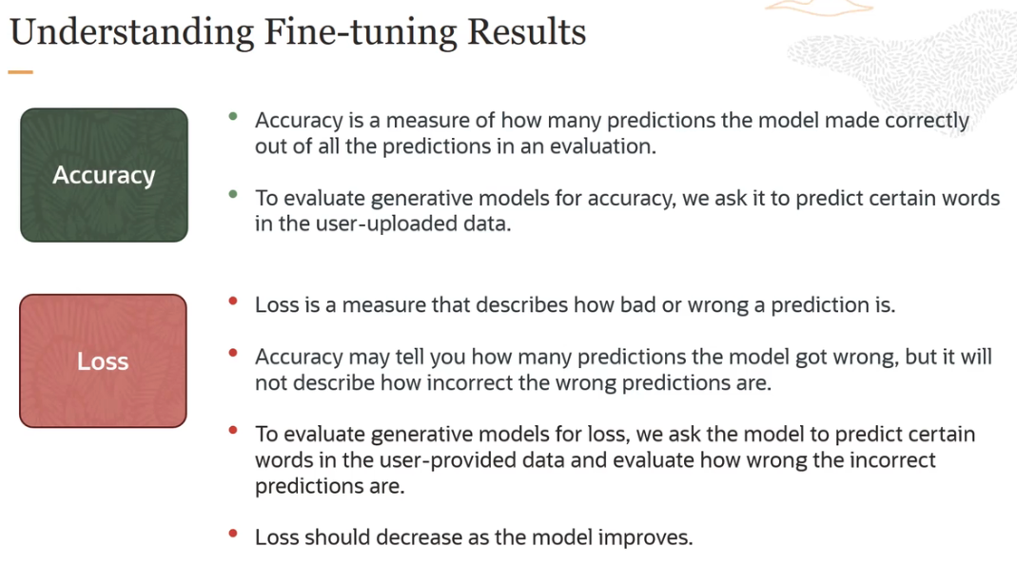



**You can create custom models by fine-tuning the base pre-trained foundational model with your own custom dataset.**

We are going to take a request coming from a human and rephrase it into the most accurate utterance that an AI virtual assistant should use.

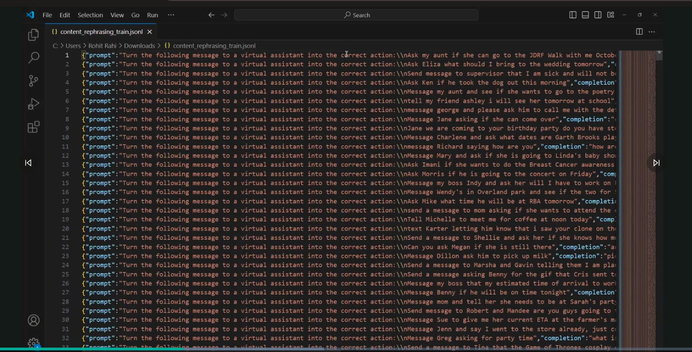

- This is referred to as a JSONL file or a JSON lines file. And this is what is used for fine-tuning custom models in OCI. Now, JSONL is a file that contains a new JSON value or object on each line.

- The file isn't evaluated as a whole like a regular JSON file would be, but rather than each line is treated as if it was a separate JSON file.

- The format which OCI requires has to have two properties. There's a property called **prompt**. And another property called **completion**. Each of these has to be on a new line. And these have to be UTF 8 encoded. Make sure that you meet those requirements, otherwise your custom model creation will fail.

- The first line says that is a human request saying " , ask my aunt if she can go to the JDRF walk with me on October 6." And the virtual assistant would rephrase it to say, "can you go to the JDRF walk with me on October 6?"

We are going to fine-tune one of the cohere command light models with this particular custom data.

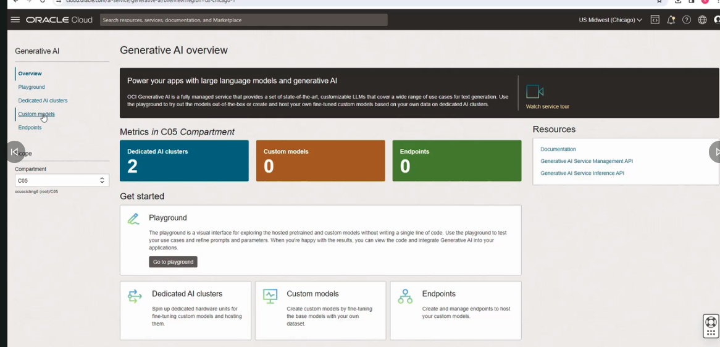

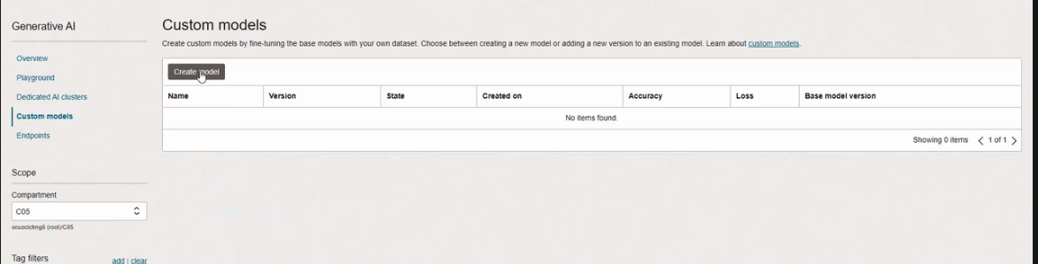

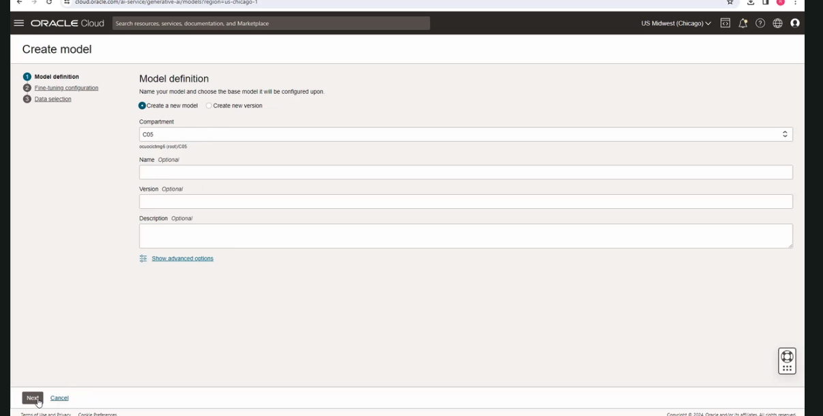

keep default value as it is and click on next

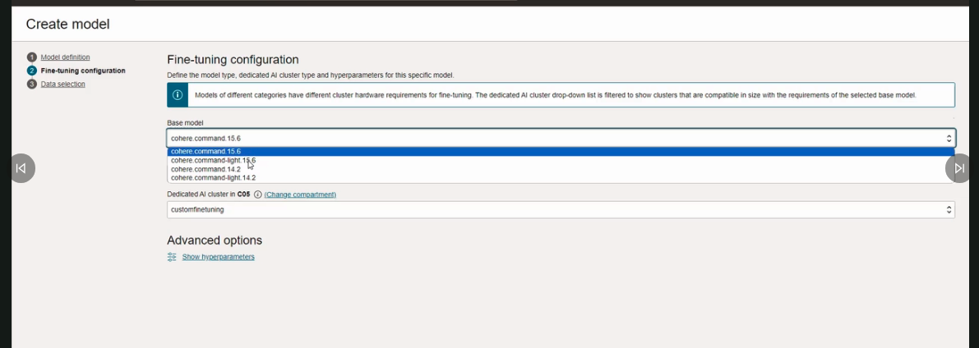

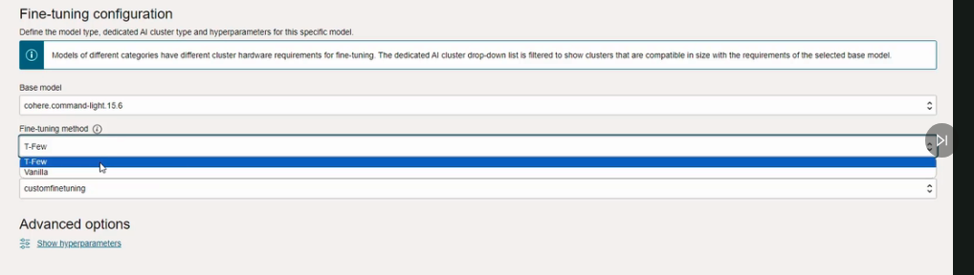

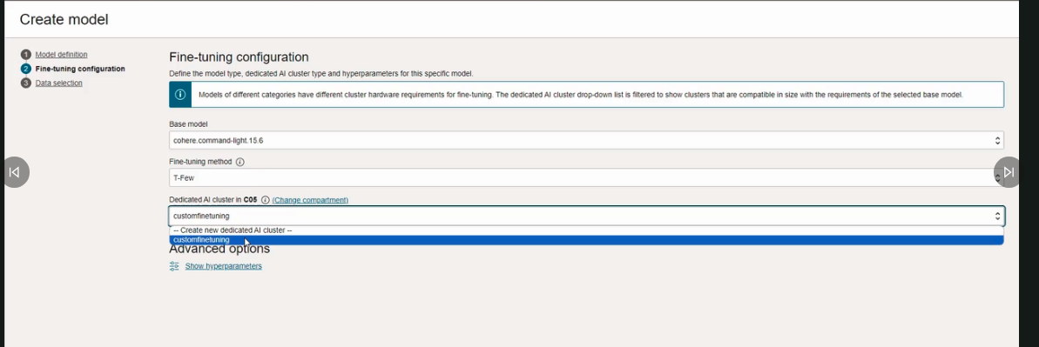

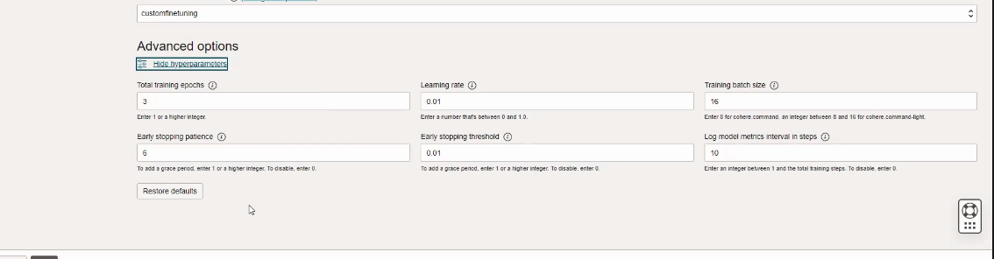

Keep it default and check how are the outputs and then accordingly change the parameter values. Click next

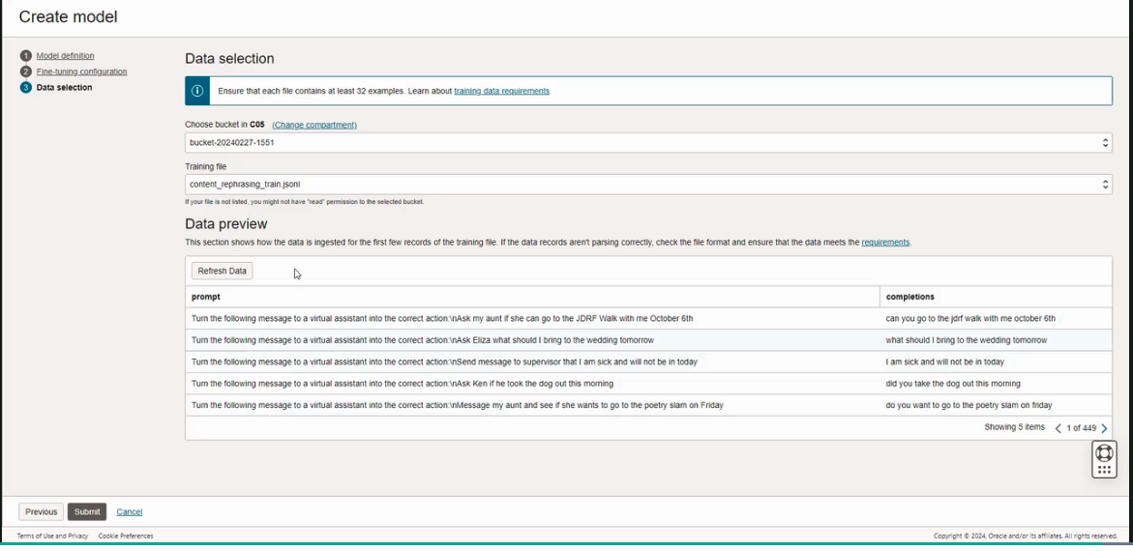

click submit.

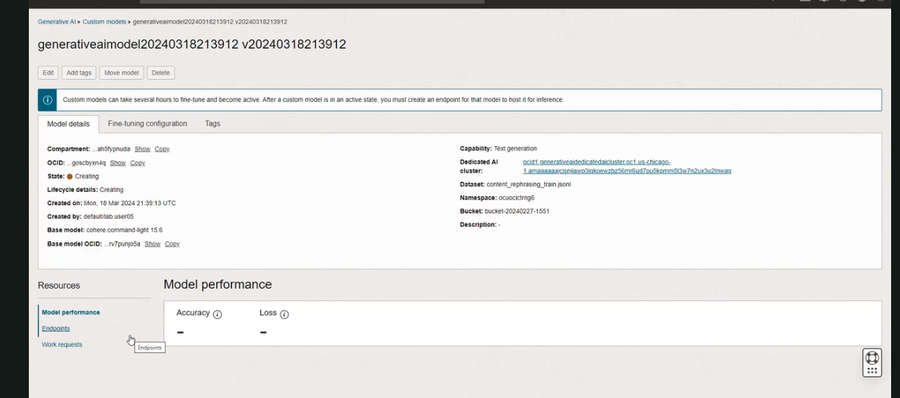

This will kick off the fine-tuning process.

In short: We gathered the training data, which came from that paper. We change it to be in a JSONL format. Then, we had the dedicated AI cluster, which was created in an earlier step. And now, we kicked off the fine-tuning process. This process will take a few minutes to complete. And once the process will get completed, we will end up with a custom model. And we can look at some of the model performance numbers, namely accuracy and loss.



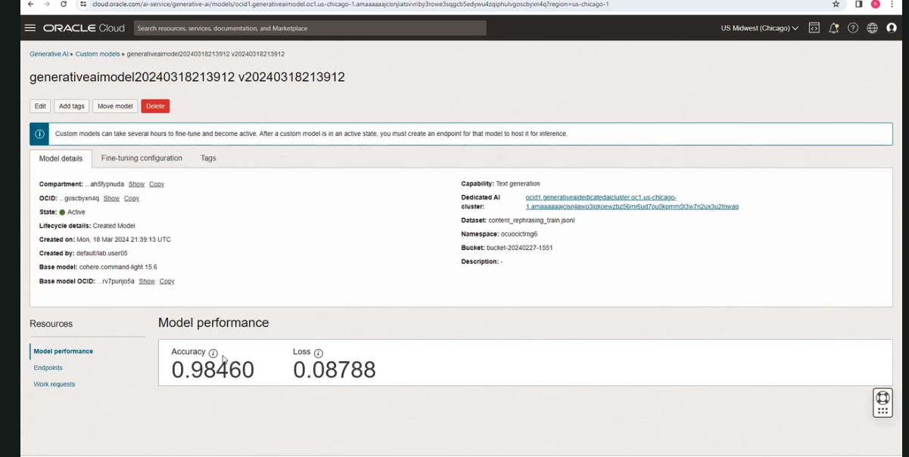

The accuracy and the loss for this particular custom model looks really good. So to click on accuracy, if you click here, you can see accuracy, definition of how we define it. And what it says here, an accuracy of 0.9 means that 90% of the output tokens match the tokens in the training data set.

And a loss of 0 means that all outputs were perfect, while a large number-- a large number for loss indicates highly random outputs. So loss is kind of trending towards 0 here.

Now create an endpoint for this custom model.

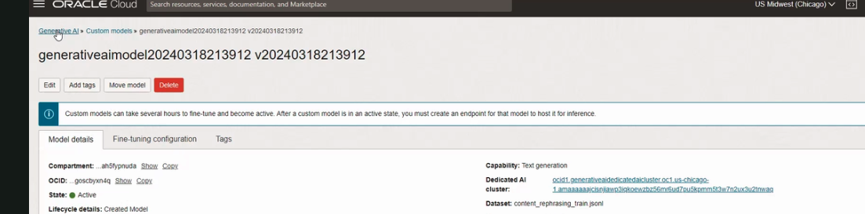

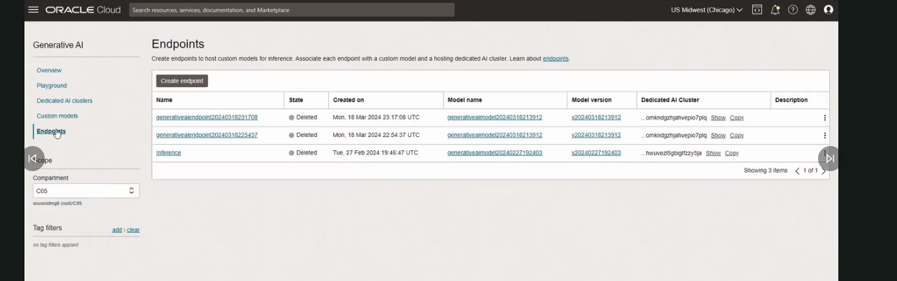

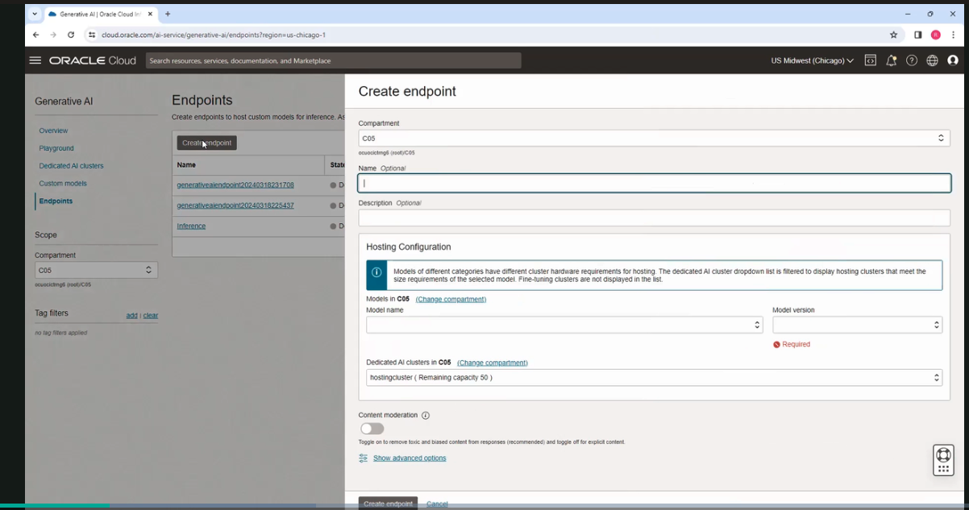

created model is also now listed

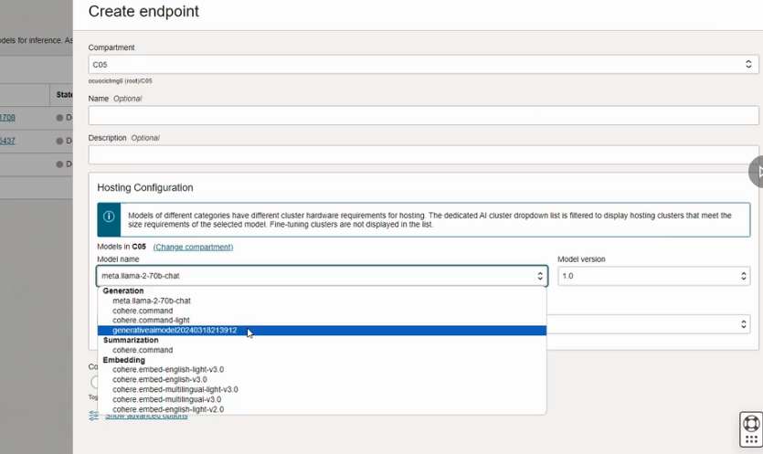

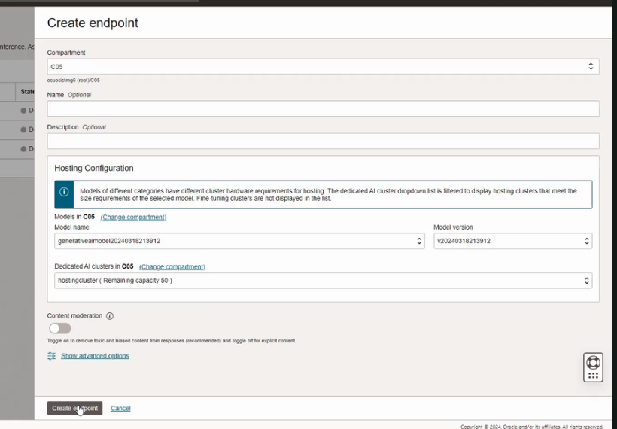

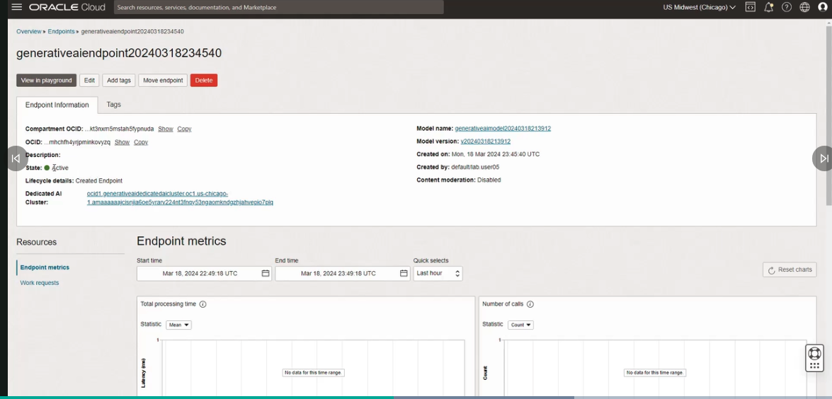

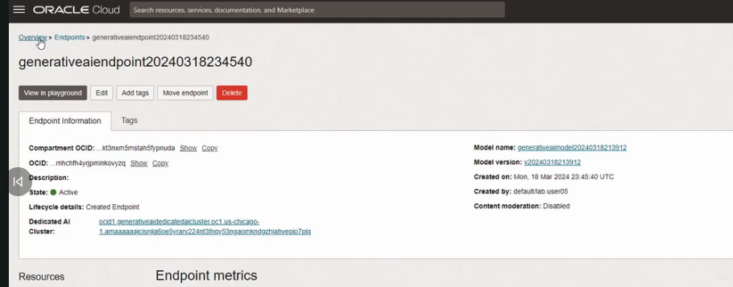

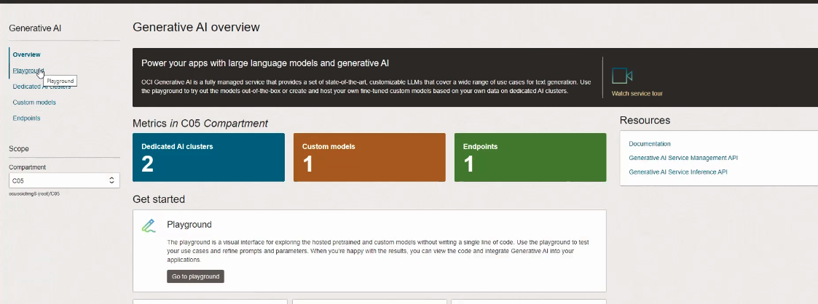

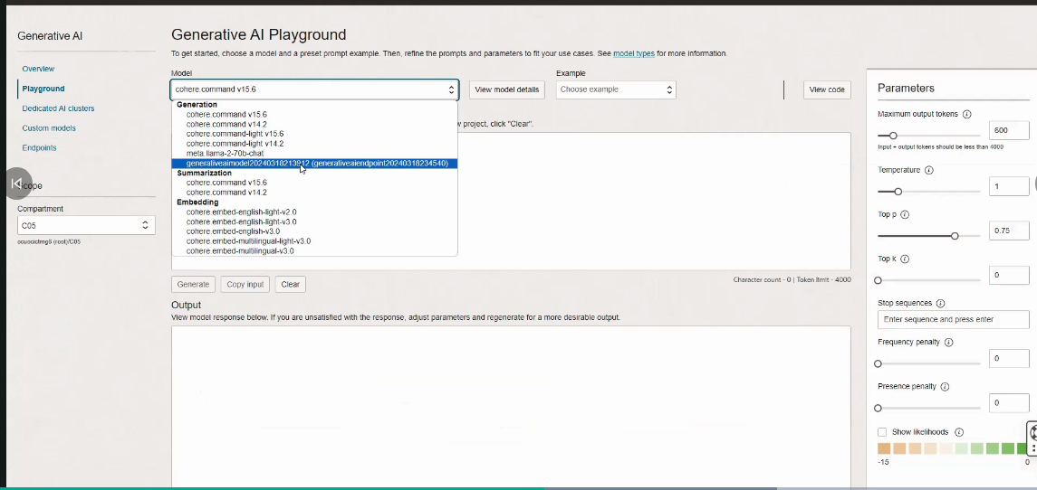

**Here we are going to make a few calls to the base model and custom model and compare the results.**

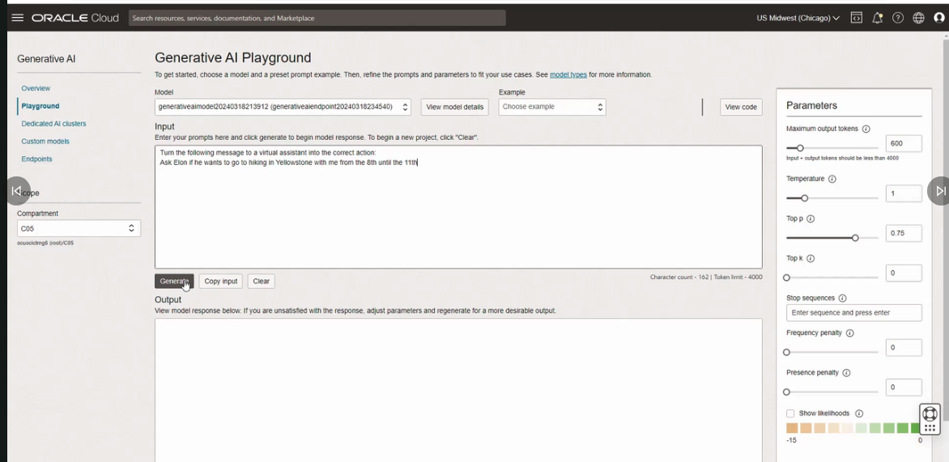

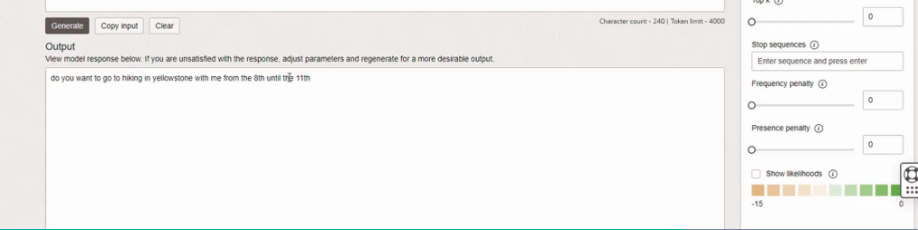

**Now change the temperature to 0 will get the same response and set to 5 then and get same response what this shows, the custom model has pretty good predictability and can produce quality results consistently, even when the temperature is 0 or 1 or 5.**

**If we change the model, the output will be different.**

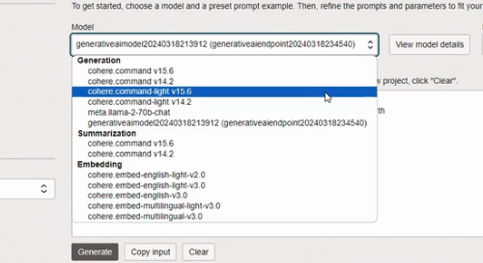

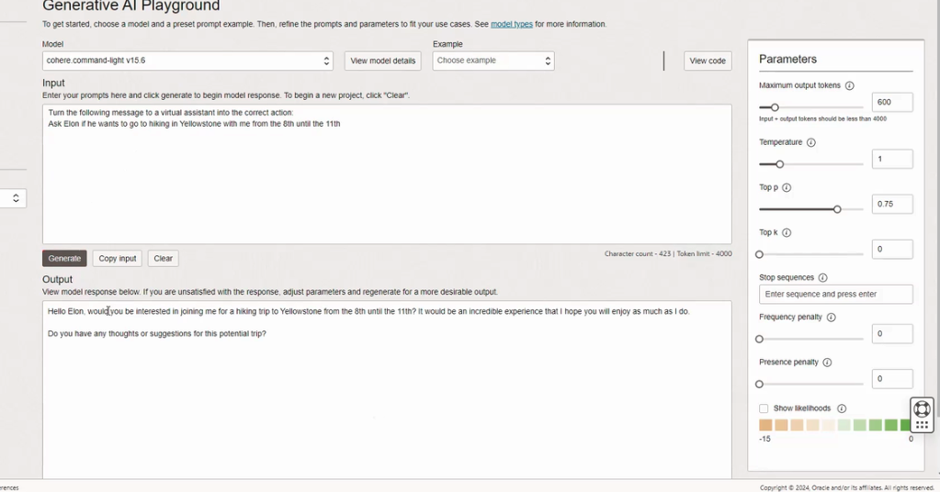



**Archietecture:**